CONSTITUTION
Of
Proactive Communities Blairgowrie & Rattray
Creating a community that is greater than the sum of its parts
(hereafter known as Pro Com)
6 December 2019
AL 1 9 January 2020
AL 2 March 2021
- The name of the association is Proactive Communities Blairgowrie & Rattray.
- Objectives of Pro Com:
- To work with the many community groups, clubs and organisations within Blairgowrie & Rattray to jointly coordinate, communicate and promote their activities to locals and visitors alike
- To work with the businesses and Business Association to jointly coordinate, communicate and promote their activities to locals and visitors alike.
- To create and continually develop an ecosystem (online platform, focus groups, familiarisation, events/activities to create a community that is greater than the sum of its parts) to sustain the coordination, communication and promotional activities of the town
- To identify, resource and manage projects that benefit the town, local community and visitors in line with the Blairgowrie & Rattray Community Action Plan
- To develop the project to incorporate marketing the wider area around the town and consider other projects as deemed suitable
- Activities – in pursuance of the objectives set out in Clause 2 above, Pro Com will:
- Liaise with community groups, voluntary bodies, businesses, the business association, local authorities, agencies, property owners, landlords, land owners and government departments as necessary to furthering the association’s objectives
- Raise funds through membership and grant applications in order to deliver the objectives outlined above
- Structure and Committee:
- The association shall consist of a committee, paid members and volunteers
- The committee shall consist of:
Chair – the Chair shall convene all meetings
Secretary
Treasurer
- Term of office shall ideally be 3 years but may be longer but no more than 5 years
- The committee will hold monthly meetings to manage activity – 3 members shall constitute a quorum
- Minutes of all meetings shall be recorded and approved at the following meeting
- The committee may co-opt members throughout the year
- Annual General Meeting (AGM) and General Special Meetings:
- The AGM shall be held within 15 months of the previous AGM
- At each AGM the committee and members will stand down and an election will be held – members may be re-elected
- New committee members shall be recorded in the AGM minutes
- A Special General Meeting may be convened at the request of at least 4 members
- Meeting Procedure:
- An agenda shall be issued ideally 1 week prior to the meeting with new items for discussion listed
- Apologies shall be noted
- Minutes from the previous meeting shall be proposed and accepted with any amendments noted and recorded – revised minutes do not need to the issued unless a major change is needed
- Actions from the previous meeting shall be updated and recorded
- Any new items shall be raised and discussed if time permits otherwise they will be added to next agenda
- Voting will be recorded, the Chair will have final say if required – any conflict of interest should be raised and actioned as necessary
- Finance and Accounting:
- A bank account will be held in the name of Pro Com with 3 members having access
- The treasurer shall keep proper accounting records and these shall be independently audited prior to the AGM.
- Any monies paid shall require approval from 2 parties – email approval is acceptable as is 2 signatures required on a cheque.
- Pro Com is a Not For Profit organisation and hence any profit left over after performing the activities and meeting the objectives of the organisation shall be distributed to the supporting organisations such as BARBA, BRDT and wider area – the distribution will be determined by the Pro Com Committee.
- Constitution – the constitution may be amended by a resolution passed by at least 3 of the committee and voted at a monthly meeting having been distributed prior to the meeting with any objections being noted.
- Property – any items purchased/obtained as part of the project shall remain the property of the association. Dissolution of the association would require any items to be disbursed as deemed appropriate by the Committee at that time.
- Dissolution – Should the Committee deem it necessary to dissolve the association it shall convene a meeting providing 21 days notice to discuss the dissolution and distribution of assets and funds. If no agreement can be found on distribution, the assets may be passed to the Blairgowrie & Rattray Community Council to be distributed at their discretion.

This Constitution was proposed on 6 December 2019 and adopted on 17 December 2019
AL1 was proposed on 9 January 2020 and adopted at the monthly meeting on 30 Jan 2020
AL2 was proposed on 18 February 2021 and adopted at monthly meeting on 18 March 2021
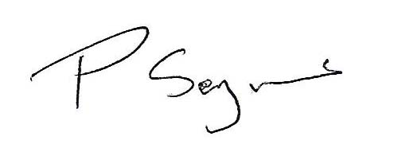
Signature Name Address Position
Phil Seymour Cargill Chair
Myreriggs Road
Coupar Angus,
Blairgowrie PH13 9HS
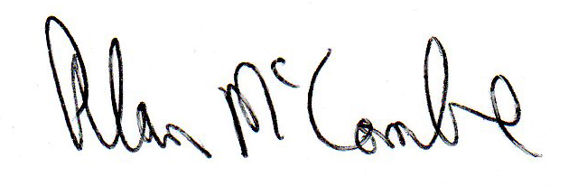
Alan McCombe 5 Blackloch Crescent Treasurer
Carsie
Blairgowrie
PH10 6RW

